Instruction Manual
Rechargeable Floor Fan
Model: HIF10OB, HIF10GW

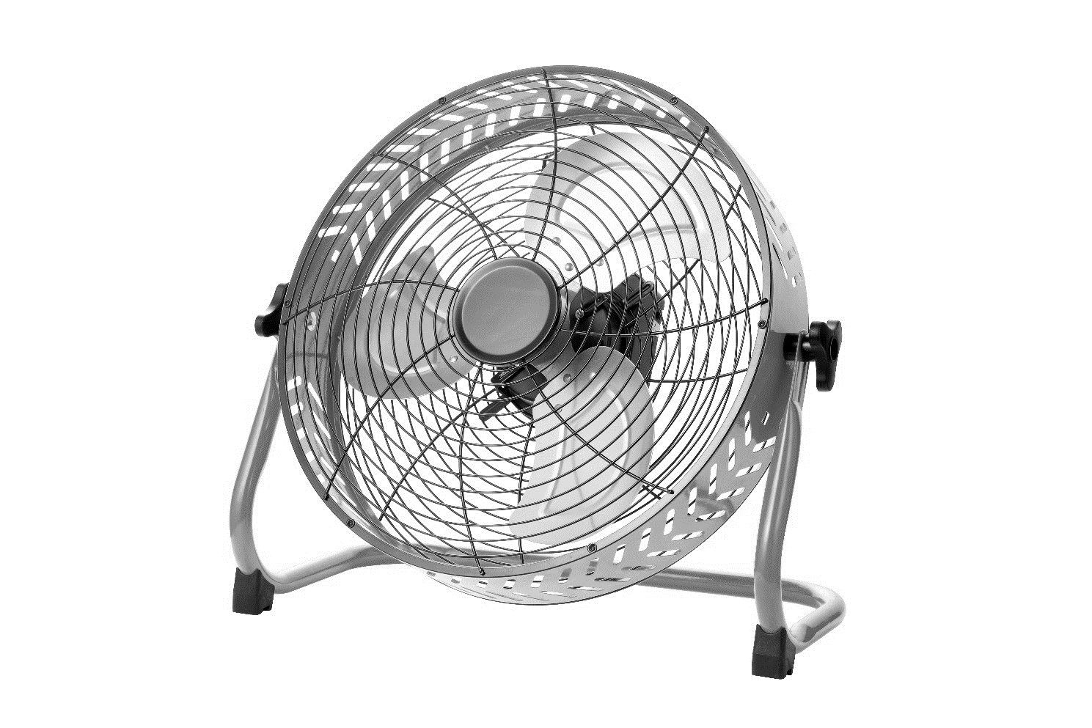

READ AND SAVE THESE INSTRUCTIONS

Please read and follow the instructions in this user manual even if you feel you are familiar with the product, and find a place to keep it handy for future reference.
For your convenience record the complete model number (located on the product identification plate) and the date you received the product, together with your purchase receipt and attach to the warranty and service information. Retain in the event that warranty service is required.
NOTE: The rating of this product (as marked on the product identification plate) is based on specific loading tests. Normal use or the use of other recommended attachments may draw significantly less power.

READ & SAVE THESE INSTRUCTIONS

WARNING: Shock Hazard
Use your fan only in dry environments. This fan is not intended
for use in a bathroom, laundry area, or similar locations, or
near sinks, washing machines, swimming pools or other
water. Never locate fan where it may fall into a bathtub or other
sources of water receptacle. Do not use in damp
environments such as flooded basements.

WARNING: Hot Surfaces
Do not touch fan motor when in use. This motor is hot when in
use, to avoid burns, do not let bare skin touch hot surfaces.

WARNING: Fire Hazard
Fans have arcing or sparking parts inside. Do not use near
combustible materials or flammable gases or sources of heat.
DO NOT USE in areas where gasoline, paint or flammable
materials are used or stored. To prevent a possible fire, do not
block air intakes or exhaust in any manner. Do not insert or allow
foreign objects to enter any ventilation or exhaust opening as this
may cause an electric shock, fire, or damage the fan.

WARNING: Electrical Shock Hazard
Do not use with damaged cord or plug. Use with adequate
electrical system that is up to code.

WARNING: to Reduce the Risk of Fire or Electric
Shock, do not use this product with any solid-state speed
control device.

DO NOT operate any fan with a damaged cord or plug or after
fan malfunctions, has been dropped or damaged in any manner.
Do not operate fan with a broken blade, safety cage or any visual
imperfections. Disconnect power before servicing. For repairs
covered under warranty, see warranty statement. For all other
repairs contact Comfort Zone® Customer Service by telephone or
mail for information and assistance.

DO NOT run power cord under carpeting. DO NOT cover cord
with throw rugs, runners or the like. Arrange cord away from
traffic area where it will not be tripped over. Avoid the use of
extension cords due to risk of fire. If an extension cord must
be used, the cord must be minimum 14 AWG and rated not
less then 1875 watts. Do not use an extension cord unless the
plug can be completely inserted into its receptacle. Unplug
the fan when not in use. Do not operate fan with its ventilation
obstructed.

Use instructions:
1. knob
Use the knob to adjust the size of the wind volume, increase the wind volume
from left to right.

2. input socket
The input voltage is 24V DC socket, please use the local charger to charge the fan.

3. output socket
The output socket is a USB socket, and the output voltage is 5V, which can
charge or power 5V products.

4. LED indicator light
The LED indicator light is divided into four grids for the power indicator light.
After charging, the four LED lights run in turn. Each one of the electric
LED lights will be lit, and the four LED lights will be long after filling.
Each discharge of an electric LED lamp will automatically go out, and the first
LED light will shine when it is 3 % of the electricity, until all LED lights
are extinguished after full discharge.
Specifications: Produce Configuration：
Product Name: Charging Fan 1. Host 1pcs
Rated voltage: DC 24V 2. Charger 1pcs
Charging time: 3 to 4 hours 3. Instructions 1pcs
Discharge time: 4-30 hours
Input voltage: DC 5V 1.5 A
Wind Regulation: Ultimate Speed Adjustment
Charger: 24V 1A

CUSTOMER SERVICE
Australian Customer Service
GAF Control (Sales) Pty Ltd
P.O Box 19
Altona North Victoria 3025
Phone: 1300 659 489
Hours: 9am-5pm (EST) Mon-Fri
www.gafcontrol.com.au
*This product may vary slightly to the product illustrated due to ongoing product development.

